LAB 11:

TASK 1:

FAHRENHEIT TO KELVIN:

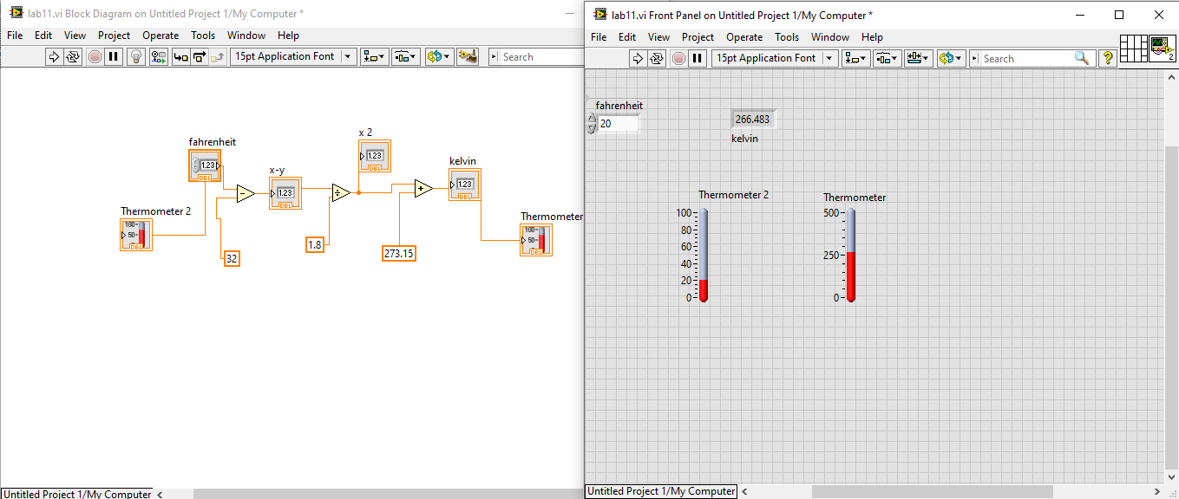

TASK 2:

Kelvin to Degree Celsius .

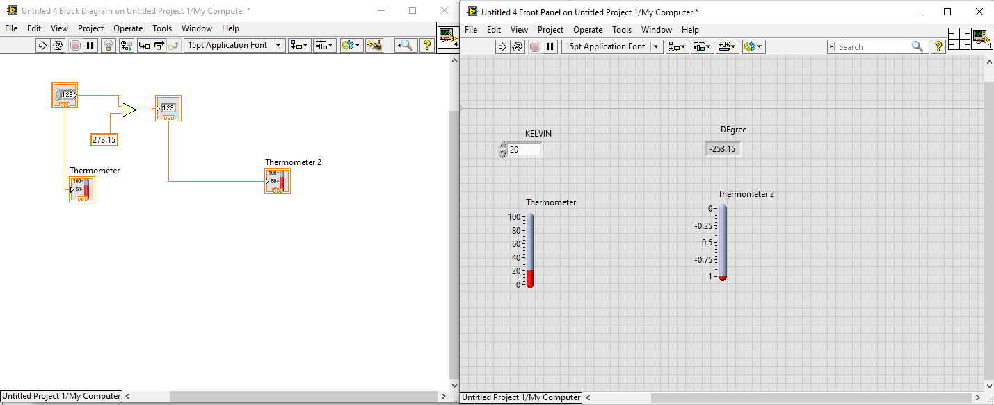

TASK 3:

convert Kelvin to Fahrenheit:

